***2020 UTIA P&T Workshop***

**Monday, 27 April 2019**

**ZOOM –**<https://tennessee.zoom.us/j/707364946>

Meeting ID: 707 364 946

Please review the 3 videos and 2 powerpoints from the 3 Deans prior to the meeting. They are available at the newly revised P&T webpage: <https://utia.tennessee.edu/2020-promotion-and-tenure-resources/>

10:00 am:  Introduction – Senior Vice President/SVC Cross (2-5 min)

10:05-10:15:  Q&A – Deans Beyl, Burns, Xin (10 min)

10:15-10:30:  Overview of Annual Reviews, Enhanced Retention, P&T overview, and Promotion to Full Professor – Neal Schrick

10:30-10:45: P&T Chair Mark Fly - formatting, guiding principles, and tips for dossiers

10:45-11:30: Committee panel discussion and additional questions for the Deans

**Here is the Zoom invitation-LOG IN INSTRUCTIONS FOLLOW:**

Topic: UTIA Promotion & Tenure Workshop

Time: Apr 27, 2020 10:00 AM Eastern Time (US and Canada)

Join from PC, Mac, Linux, iOS or Android: <https://tennessee.zoom.us/j/707364946>

Or iPhone one-tap (US Toll):  +13126266799,707364946#  or +16468769923,707364946#

Or Telephone:

    Dial:

    +1 312 626 6799 (US Toll)

    +1 646 876 9923 (US Toll)

    +1 346 248 7799 (US Toll)

    +1 669 900 6833 (US Toll)

    +1 253 215 8782 (US Toll)

    +1 301 715 8592 (US Toll)

    Meeting ID: 707 364 946

**And here are the instructions for ensuring one is signed into Zoom properly:**

In order to access the secure Zoom meeting for the UTIA Promotion & Tenure Workshop, you must be signed into your Zoom client with your UT Zoom account. Please follow these instructions.

If you have never signed into the Zoom client, you may see this screen. Click **Sign In**

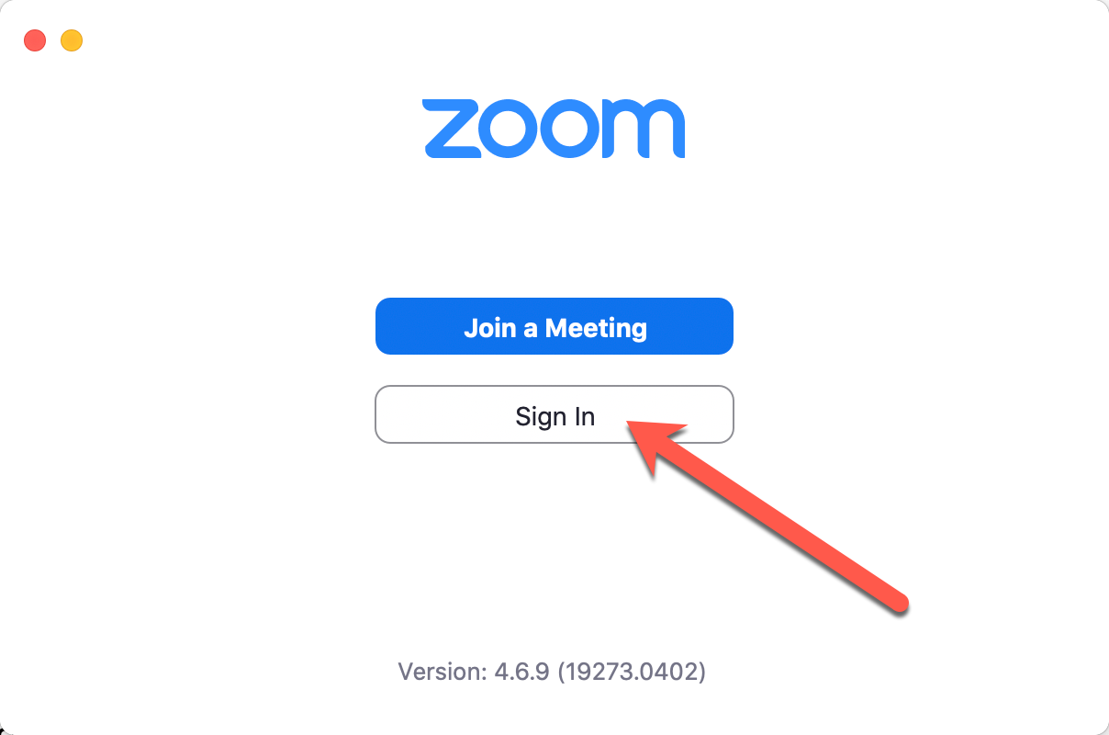

If you are already signed into your Zoom client, sign out by clicking on your initials/portrait in the top right and selecting **Sign Out**.

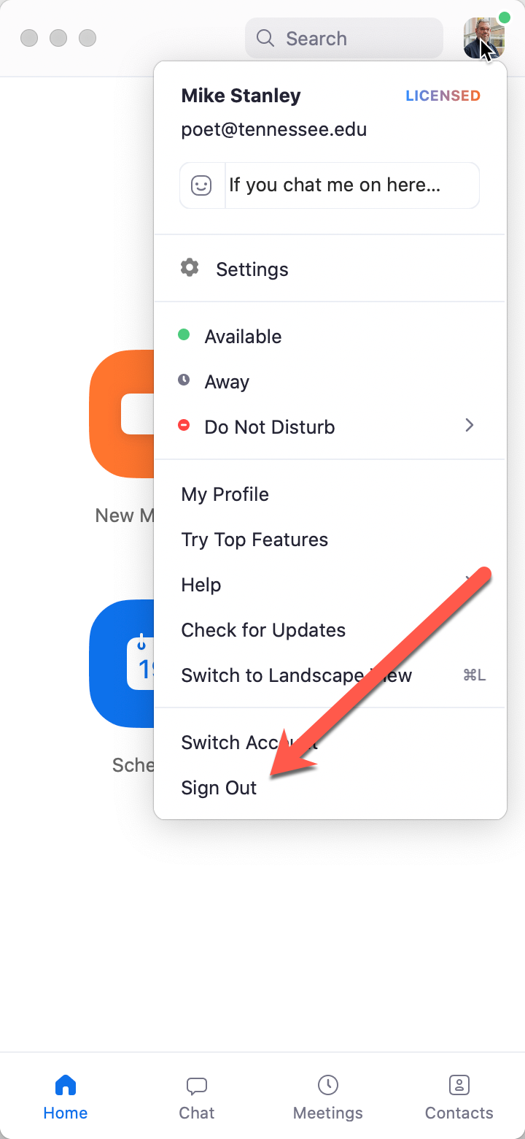

Now sign in, but make sure you ignore the section on the left. Click on **Sign in with SSO**

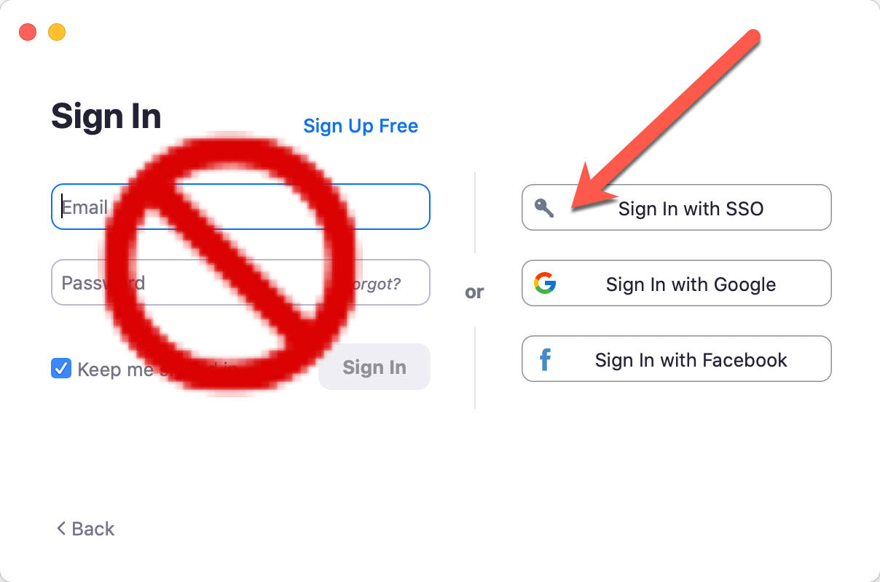

Ensure you have **tennessee** (not utia) in the box here, and click **Continue**.

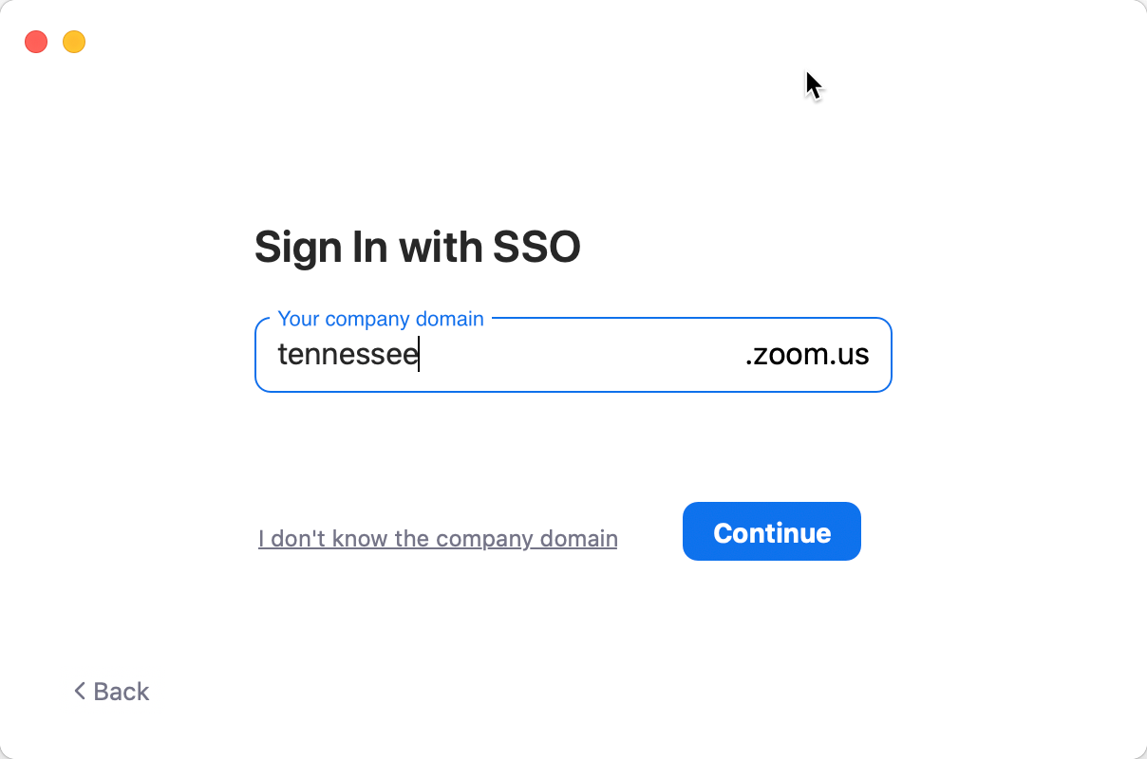

That should bounce you out to the familiar UT login page, and once you’re signed in, your browser should ask if it’s OK to run Zoom again.