

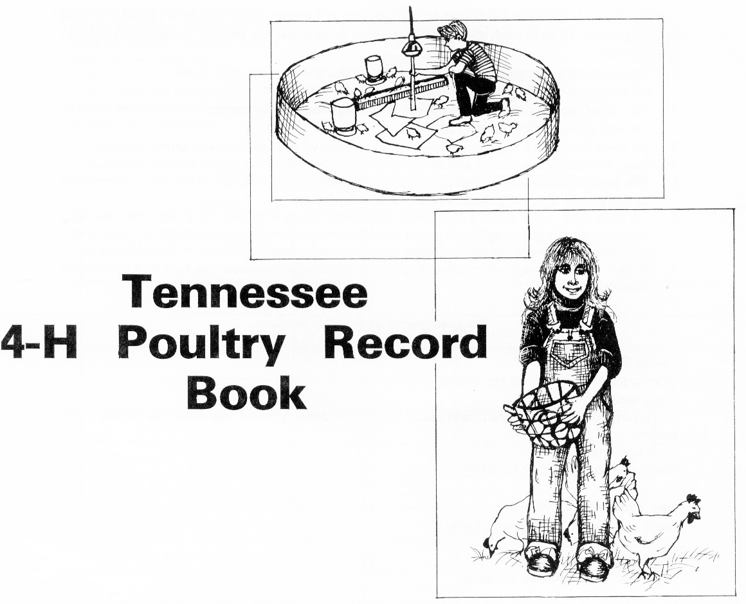

Name of Member

Address

Age |  | Grade in School

County

Leader

INSTRUCTIONS

This record book was developed to aid 4-H’ers in keeping more accurate records in their poultry project. To determine the financial situation for your poultry project, good record keeping is important.

- Keep a record of expenses and receipts for pullet growing on page 3.

- The pullet growing financial statement is on page 4. This record should be completed at the end of the pullet growing project.

- On page 5, write a project story that tells about your experiences in pullet growing.

- Keep a record of expenses and receipts for egg production on pages 6 and 7.

- The financial summary for egg production is on page 8. This record should be completed at the end of the egg production phase of the project.

- On page 9, write a story discussing your experiences with the egg production project.

- On page 10, keep a monthly record of mortality that occurs during the pullet growing or egg production phases of the project. Also, keep a record showing all uses of the chicks or hens.

- A daily record for egg production on page 11 can be removed and kept in a convenient location.

REQUIREMENTS OF POULTRY PROJECTS

Pullet Growing Project

- Start a minimum of 25 pullet chicks.
- Keep records.
- Participate in the county show and sale if the chicks were received free from the county chick project.
- Give demonstrations.
- Read and study poultry literature.

Egg Production Project

- Start a minimum of 10 laying hens.
- Keep records.
- Give demonstrations.
- Read and study poultry literature.

H. Charles Goan
Former Professor and Leader
Animal Science – Poultry
EXPENSES AND RECEIPTS FOR PULLET GROWING

Expenses and receipts should be recorded on this page starting at the time you receive your chicks. At the end of the pullet growing project, the expenses and receipts are to be transferred to the Pullet Growing Financial Statement.

Include in expenses the value of: Include in receipts the value of:
Chicks bought or given free Pullets kept for egg production
Feed purchased – amount, kind and cost Pullets sold
Home-grown grain used Birds sold for meat
Litter Birds used at home for meat
Cost of heat for brooding Prize money
Equipment purchased or homemade Miscellaneous receipts
Miscellaneous expenses

Expenses |  |  |  | Receipts
Date | Description and quantity | $ |  | Date | Description and quantity | $
 | TOTAL $ |  |  |  | TOTAL $
PULLET GROWING FINANCIAL STATEMENT

Date project started |  |  | Date project completed

EXPENSES:

Chicks |  | No. |  | Cost $

Equipment purchased |  | Cost $

Feed (Starter and grower) |  | Lbs. |  | Cost $

Home grain |  | Lbs. |  | Cost $

Miscellaneous expenses |  | Cost $

Pullets returned to county show and sale |  | No. |  | Value $

TOTAL EXPENSES |  | $

RECEIPTS:

Sale of pullets |  | No. |  | Value $

Pullets kept for egg production |  | No. |  | Value $

Male birds kept |  | No. |  | Value $

Birds used at home for meat |  | No. |  | Value $

Miscellaneous receipts |  | Value $

TOTAL RECEIPTS |  | $

TOTAL EXPENSES |  | $

NET GAIN OR LOSS |  | $

PROJECT STORY FOR PULLET GROWING

Write an interesting story telling what you had done this year with your pullet growing project. Items that can be mentioned are (1) preparations made before the chicks arrived, (2) the brooding, feeding, watering, sanitation and general management program, and (3) the pullet show and sale.

EXPENSES AND RECEIPTS FOR EGG PRODUCTION

Expenses and receipts should be recorded on this page starting at the time pullets reach maturity and begin laying eggs. At the end of the egg production year, the expenses and receipts are to be transferred to the Egg Production Financial Statement.

Include in expenses the value of: Include in receipts the value of:
Pullets transferred from the pullet Hens remaining at the end of the egg
growing project, feed purchased, production year, eggs sold, eggs eaten
home grown grain and oyster shell, at home, hens used for meat and
litter, equipment, egg cartons and miscellaneous items.
miscellaneous items.

Expenses |  |  |  | Receipts
Date | Description and quantity | $ |  | Date | Description and quantity | $
 | Total transferred to |  |  |  | Total transferred to
 | next page | $ |  |  | next page | $

EXPENSES AND RECEIPTS FOR EGG PRODUCTION (continued)

Expenses |  |  |  | Receipts
Date | Description and quantity | $ |  | Date | Description and quantity | $
 | TOTAL $ |  |  |  | TOTAL $
EGG PRODUCTION FINANCIAL STATEMENT

Date project started |  |  | Date project completed

EXPENSES:

Birds on hand from previous year |  | No. |  | Cost $

Feed purchased |  | Lbs. |  | Cost $

Home grain fed |  | Lbs. |  | Cost $

Equipment purchased |  | Cost $

Pullets reared or purchased |  | No. |  | Cost $

Other expenses |  | Cost $

TOTAL EXPENSES |  | $

RECEIPTS:

Eggs sold |  | Doz. |  | Value $

Eggs used at home |  | Doz. |  | Value $

Hens sold |  | No. |  | Value $

Hens used at home for meat |  | No. |  | Value $

Other receipts |  | Value $

Birds on hand at end of year |  | No. |  | Value $

TOTAL RECEIPTS |  | $

TOTAL EXPENSES |  | $

NET GAIN OR LOSS |  | $

PROJECT STORY FOR EGG PRODUCTION

Write an interesting story about your egg production project. You should describe your management program which would include feeding, lighting, record keeping, egg gathering and general sanitation. In addition, describe the market for any eggs or hens you may have sold. Pictures or illustrations may be useful.

MORTALITY RECORD FOR PULLET GROWING

 | Jan | Feb | Mar | Apr | May | June | July | Aug | Sept | Oct | Nov | Dec | TOTAL
No.
Died
No.
Culled

DEPLETION SUMMARY

Number

Birds died

Birds culled

Birds sold

Birds consumed at home

Male birds remaining

Pullets kept for egg production

MORTALITY RECORD FOR EGG PRODUCTION

 | Jan | Feb | Mar | Apr | May | June | July | Aug | Sept | Oct | Nov | Dec | TOTAL
No.
Died
No.
Culled

DEPLETION SUMMARY

Number

Hens died

Hens culled

Hens sold

Hens consumed at home

Hens remaining

DAILY EGG RECORD

Date | Jan | Feb | Mar | Apr | May | June | July | Aug | Sept | Oct | Nov | Dec
1
2
3
4
5
6
7
8
9
10
11
12
13
14
15
16
17
18
19
20
21
22
23
24
25
26
27
28
29
30
31
Total No. Eggs
Total Doz. Eggs

Programs in agriculture and natural resources, 4-H youth development, family and consumer sciences, and resource development.
University of Tennessee Institute of Agriculture, U.S. Department of Agriculture and county governments cooperating.
UT Extension provides equal opportunities in programs and employment.

